Adrian Grimm

WDD229 – Advanced Web design

Week 9 – AdWords & Critique

3/16/2020

**Original:**

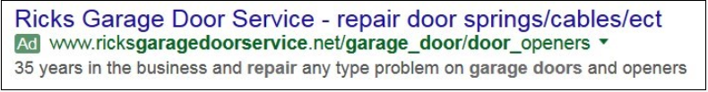

**Update:**

**Ad** [www.ricksgaragedoorservice.net](http://www.ricksgaragedoorservice.net)

**Rick’s Garage Door Service | Repairing Door Springs and Cables**

35 Years of expert service and repair. We service any model garage door and opener.

**Explanation:**

Shortening the link make it look more succinct and professional. Moving the link to the top of the ad and placing the business name in the middle of the ad draws the user to the ad. Lastly, changing the USP (Unique Selling Proposition) adds more keywords and is worded to be easier for potential customers to read quickly.